**Correo gmail**

Correo = [wilderavilacompany@gmail.com](mailto:wilderavilacompany@gmail.com)

Contraseña = wilderavilacompany100321

[**https://co.000webhost.com/**](https://co.000webhost.com/) **gratis para pruebas**

Correo = [wilderavilacompany@gmail.com](mailto:wilderavilacompany@gmail.com)

contraseña= Wilderavilacompany100321

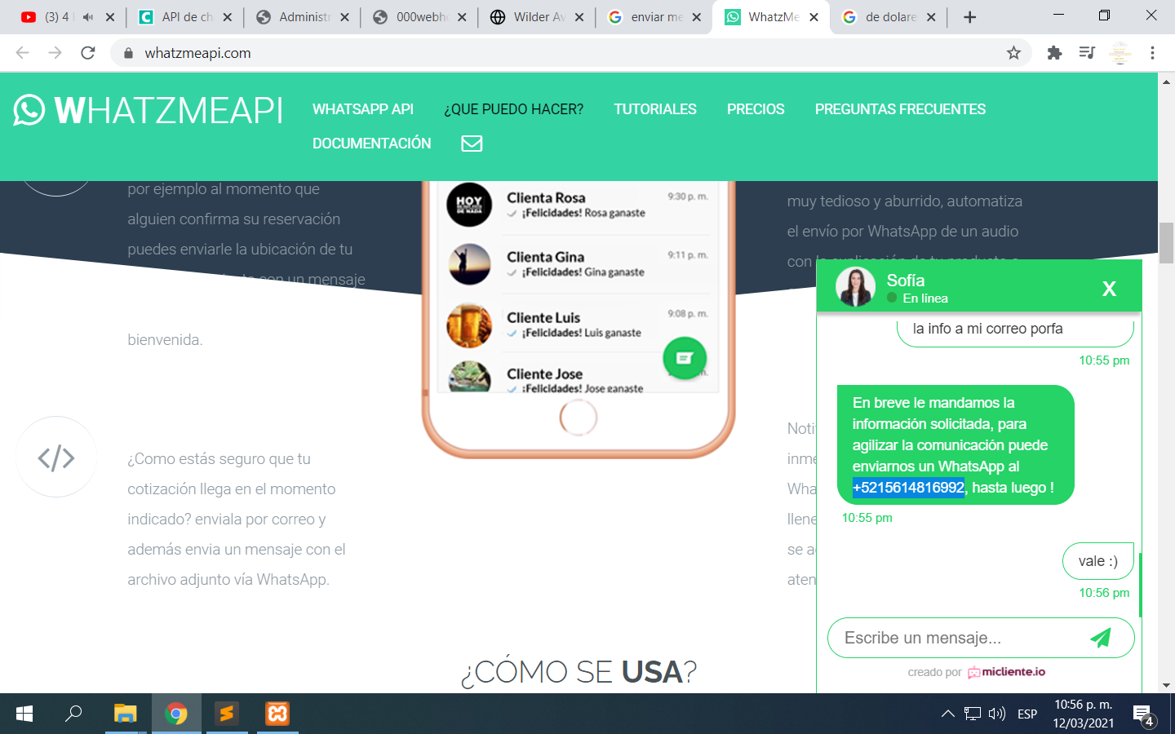

h%)OhFveo^L)%1cWsM$y